**Disentangling the drivers of mountain date palm population dynamics in a multi-use landscape using integral projection models**

**Authors:** Lisa Mandle and Tamara Ticktin

**Abstract:**

Little is known about the interactive effects of multiple forms of disturbance – natural or anthropogenic – on plant population dynamics. This gap in knowledge limits our ability to effectively manage plant populations in the face of changing disturbance regimes resulting from growing human influence on ecological processes. Fire, grazing and harvest of wild plants are three widespread and commonly co-occurring land management activities in the tropics that contribute to altered disturbance regimes with increasing human pressures. In this study, we use integral projection models to investigate the effects of and interactions between these three activities on the population dynamics of mountain date palm (*Phoenix loureiri*) in the Western Ghats, India. Our models are based on 14 palm populations and over 2,300 palm individuals monitored from 2009-2011. Our results demonstrate that fire, grazing and harvest affect both palm vital rates and projected population dynamics. We find non-linear effects of grazing and harvest on projected population growth rates, with palm populations exhibiting resilience to low intensities of grazing and harvest, but strong declines with increasing intensities. Palms also show resilience to fire, with increased growth compensating for reduced survival in the 1-2 years following fire. In addition, we found that intensities of grazing and harvest were higher in populations with fire in the past 1-2 years compared populations without recent fire, and that intensities of harvest were lower in more intensively grazed populations. Together, these results illustrate the necessity of understanding the interactive effects of these three co-occurring forms of disturbances. Because both grazing and harvest intensities are driven by fire, managing fire frequency will be especially critical to ensuring the persistence of mountain date palm populations in human-managed ecosystems.

**Keywords:** Western Ghats, fire, grazing, non-timber forest product, harvest, demography

**Introduction:**

Ecologists have recognized the importance of disturbance in structuring plant populations and communities for decades (Connell and Slatyer 1977, Sousa 1984, Pickett and White 1985). Numerous studies have assessed the effects of individual forms of disturbance on plant population dynamics (see review by Crone *et al.* 2011). As human activities increasingly dominate ecosystem processes (Sanderson et al. 2002, Ellis and Ramankutty 2008, Gardner et al. 2009), determining the combined effects of multiple natural and anthropogenic disturbances is critical for predicting and managing for the consequences of human-driven changes to disturbance regimes. Yet despite recognition of the importance of interactions to ecological processes (Agrawal et al. 2007, Didham et al. 2007), interactions among multiple forms of disturbance on plant population dynamics remain poorly understood, especially for long-lived species(Farrington et al. 2009, Midgley et al. 2010).

Fire, grazing and wild plant harvest are three widespread, often co-occurring forms of disturbance affecting plant populations. In many ecosystems today, these disturbances occur with greater frequency or intensity than in the past due to human activities (Asner et al. 2004, Bond et al. 2005, Kareiva et al. 2007). Fire and grazing regimes are recognized as having reciprocal effects on each other (Fuhlendorf et al. 2008, Midgley et al. 2010, Kirkpatrick et al. 2011). Importantly, grazing intensity often increases following fire (e.g., Wilsey 1996; Winter *et al.* 2011).While many studies have documented the consequences of this fire-grazing relationship for plant communities (e.g., Archibald et al. 2005, Collins and Calabrese 2011), much less is known about its effects on plant population dynamics (but see Staver et al. 2009). Grazing has also been shown in some cases to reduce the intensity of plant harvest, either by hiding plants from harvesters (Farrington *et al.* 2009) or by damaging plant parts so that they are not worth harvesting (Mandle and Ticktin, in review). Understanding how changes in the frequency and intensity of these common forms of disturbance, and the interactions among them, affect plant population dynamics will be critical for conservation in human-managed landscapes.

In addition to the consumptive effects of disturbance through removal of biomass, many forms of disturbance may also have nonconsumptive effects on plant population dynamics. Grazing, for example, may alter plant population dynamics due to trampling or compaction of soil (Rooney 2003, Heckel et al. 2010). Separating consumptive from nonconsumptive effects in demographic studies has proved difficult (Maron and Crone 2006), and most studies have not done so. However, ignoring nonconsumptive effects risks under- or over-estimating the effects of disturbance.

Palms(*Arecaceae*) are a particularly useful system in which to study the effects of multiple forms of disturbance on the demography of long-lived plants because palm populations commonly experience multiple natural and anthropogenic disturbances including fire, harvest (of leaves, fruit and stems) and grazing by wild animals or livestock (Endress et al. 2004, Souza and Martins 2004, Pulido et al. 2007, Lopez-Toledo et al. 2011). At the same time, because palms are common to and an important part of ecosystems around the globe and provide valuable resources for so many people (e.g., Montúfar *et al.* 2011), knowledge about their responses to multiple forms of disturbance can also inform management.The effects of harvest on palm population dynamics have been well studied, though our understanding of the effects of leaf harvest come primarily from the neotropics, while studies from Asia have focused on stem-harvested rattans(Zuidema et al. 2007, Schmidt et al. 2011).Studies of the effect of herbivory and fire on palm population dynamics are much less common (Montúfar *et al.* 2011).As studies of the demographic effects of interactions among disturbances are rare across all plant species, little is known about interactions among these forms of disturbance on palms (but see Berry, Gorchov, and Endress, 2011; Endress et al., 2004).

In this study, we examine the effects of and interactions among grazing, leaf harvest and fire on the population dynamics of mountain date palm (*Phoenix loueriri*) in the Western Ghats, India. With its high biodiversity, long history of human land use and high human densities (Chandran 1997, Myers et al. 2000, Cincotta et al. 2000), the Western Ghats region of India provides an ideal context for investigating interactions among natural and anthropogenic disturbances and the effects of human alteration of disturbance regimes.

We use integral projection models (IPMs, Easterling, Ellner, and Dixon 2000; Ellner and Rees 2006) developed with two years of data from 14 palm populations with varying histories of fire and intensities of grazing and leaf harvest. The ability to model population dynamics as a function of continuous variables, including environmental gradients, is a strength of IPMs and an important advance on traditional population projection matrices.IPMs have recently been used to explore the response of plant population dynamics to gradients of herbivory and resource availability (Rose et al. 2005, 2011, Hegland et al. 2010, Dahlgren and Ehrlén 2011). However, we know of no application of IPMs to understanding interactions between multiple forms of disturbance, despite the particular suitability of IPMs to such situations.

In previous research, we used a manipulative experiment to examine the effects of grazing, harvest and fire on individual palm vital rates (survival, growth and reproduction; Mandle and Ticktin, in review). However, the way in which these impacts at the individual level scale up to influence population-level dynamics remains unknown. In addition, the manipulative experiment was carried out at a single site; whether the observed palm responses can be generalized across sites with differing histories of harvest and herbivore communities has yet to be determined.

In this study, we aim to answer four questions: 1) What are the effects of and interactions among grazing, harvest and time since fire on the vital rates of mountain date palm individuals and the projected dynamics of mountain date palm populations? 2) Does the intensity of grazing decline with increasing time since fire? 3) Does the intensity of harvest decline with increasing grazing intensity? and 4) What are the implications of our findings for management of palm populations?

Based our previous manipulative experiment (Mandle and Ticktin, in review) and other studies of palm population dynamics (Endress et al. 2004, Zuidema et al. 2007), we expected that harvest and grazing both would reduce projected population growth rates. We expected to find a greater negative effect of grazing than harvest because grazing, but not harvest, was found to reduce palm survival. Survival is frequently a high-sensitivity vital rate in long-lived species such as palms (Franco and Silvertown 2004, Zuidema et al. 2007). For this same reason, we expected fire – both during the year of the burn and 1-2 years after – to have a net negative effect on palm population growth rates because of reduced survival, despite evidence of increased growth following fire. We also anticipated finding higher grazing intensities in populations with recent fire. Based on the results of our manipulative experiment, we expected that lower harvest intensities would occur with higher grazing intensities, especially in populations without fire in the past 1-2 years.

**Methods**

***Study species and area***

Mountain date palm (*Phoenix loueriri* Kunth) is widely distributed across sub-Himalayan Asia, from India through southern China into Taiwan and the Philippines, where it occurs from sea level to 1700 m in open grasslands and scrublands or forest understory (Barrow 1998).The species is dioecious and can reproduce clonally by basal suckers.Within our study area, nearly all genets had multiple genetically identical stems (ramets). Individual palms can grow up to 5 m tall, but in our study site they remain shrubby with stems less than 30 cm tall, as is common in dry and disturbed areas (Barrow 1998).

To understand the effects of disturbance on mountain date palm population dynamics, we selected 14 mountain date palm populations in savanna-woodlands across 5 sites to represent variation in the intensities of grazing, harvest and time since fire (Table 1). Our study sites encompassed three reserve forests, one protected area and a remnant forest fragment on privately owned land. The protected area was managed as a reserve forest until it was declared a wildlife sanctuary in 1973. Collection of wood from standing trees has been banned since 1987 (Shankar, Hegde, et al., 1998), while commercial non-timber forest product extraction was banned in 2004.

Palm leaves may be browsed by both wild and domestic ungulates. Livestock from local villages were present in two reserve forest sites (Table 1).Wild ungulates, primarily gaur (*Bos gaurus*) and sambar deer (*Rusa unicolor*), were also present at study sites.In addition the Asian elephant (*Elephas maximus*) consumes palm leaves and the stems of young plants (Sukumar 1990), and may uproot palms.Elephants were detected in all study sites except the forest fragment, though were not recorded from dung transects within the study plots at one reserve forest.Porcupine(*Hystrix indica*) may also consume the underground portion of the palm.

In South India, mountain date palm leaves of ~60 cm in length or longer are harvested for hand brooms.Commercial harvest of mountain palm leaves by local communities takes place in reserve forests managed by the Forest Department. Ungulate grazing removes only the upper part of the palm leaf, whereas harvest removes the full leaf and part of the petiole. Ungulates preferentially graze from leaves that have not fully expanded, while harvesters collect larger, fully developed leaves (L. M., personal observation).

Ground fires, often set by local people to manage for fodder and harvested plant species, are a frequent occurrence. Fire may also be used to manage mountain date palm populations, as palms are perceived to produce brighter green, higher quality leaves after fire (Mandle et al, in review). Within reserve forests, it is rare to find areas that have not burned within the past three years; fires occur with less frequency in the protected area. The fire return interval has likely increased over the past century (Kodandapani et al. 2004).

***Study design and data collection***

Within each of the 14 study populations, we established a plot containing approximately 150 palm individuals. Plot size varied with palm density, and ranged from 12.5-200 m2 (mean = 62 m2, median = 42.5 m2). Palms were measured when plots were established in July-August 2009, and then censused annually through 2011. For every ramet, at each census we measured the width of the petiole of longest leaf. We used the petiole width of the longest leaf as an indicator of plant size because most palms did not have above-ground stems and because petiole width correlates with survival, growth and reproduction in this and other palm species (e.g., Joyal 1996). For reproductive ramets, we recorded the number of flowering or fruiting stalks produced and the sex of the ramet. We monitored over 2,300mountain date palm ramets in total.

During re-monitoring in 2010 and 2011, new seedlings and vegetative sprouts were also tagged and measured. Vegetative sprouts were assumed to originate from the nearest ramet (here referred to as the “mother ramet”). We recorded the number of grazed leaves, harvested leaves and the total number of leaves (including harvested or grazed leaves that still had green petioles) per ramet. Due to similarities in dentition between domestic and wild ungulates present at the study site, we were unable to differentiate herbivory on palms by livestock from herbivory by wild grazers. Recent elephant herbivory could be recognized where ramets had been uprooted.

Ramets within genets are connected by underground stems. In many cases, distinct genets could be identified based on patterns of growth, by exposed stems or by locating the underground stem at the end of the study. In cases where this was not feasible, we assumed that ramets separated by more than~25 cmbelonged to distinct genets.

To account for possible environmental differences among plots that could explain differences in palm demographic rates, we measured canopy openness at the start of the study using hemispherical photos taken 1 m off the ground, with a total of 8 photos per population. We analyzed photos with Gap Light Analyzer version 2 (Frazer *et al.* 1999).

***Analysis of vital rates***

We used linear and generalized linear mixed-effects models to model the effects of grazing, harvest, fire and important covariates on palm ramet vital rates (survival, growth, fertility and vegetative reproduction; Table S1).Random effects included ramets nested within genets within populations within sites, as well as year. Fixed explanatory variables included the main effects of fire, harvest, grazing, as well as covariates – ramet size (petiole width), density (ramets per genet) and canopy openness. Initial full models included all two-way interactions among grazing, harvest and fire as well as two way interactions between grazing, harvest, fire and the covariates (ramet size, density and canopy openness). Quadratic terms were added where necessary based on checks of model residuals. Full models were reduced in a backwards stepwise process, sequentially dropping the least significant fixed-effect term in the model, using AIC as the criteria for determining whether to drop or retain a given factor. All analyses were completed in R 2.14.0(R Development Core Team 2011) using lme4 (Bates et al. 2011) and nlme packages (Pinheiro *et al.* 2011).

Grazing and harvest were treated as continuous variables and measured as the proportion of leaves grazed or harvested per ramet and per genet. Fire was treated as a categorical variable with three levels: populations exposed to fire within the previous year (F0), populations with fire in the past 1-2 years (F12) and populations without fire for 2 or more years (NF). We chose these categories because of similarities in vital rates within categories and because of some uncertainty in time since fire for populations that had not burned in more than three years. Because only three populations were exposed to fire during the study period, and these fires all occurred within a single site (Pillur Reserve Forest) within a single year (2010-2011), we initially excluded data from these three F0 populations from the analysis. After selecting the best set of predictors using F12 and NF populations, we then re-ran the analysis with the F0 populations included and tested for the effects of fire category, and interactions between fire, starting size, harvest and grazing.

Because ramet-level intensities of grazing and harvest were available only for surviving plants, we modeled survival as a function of grazing and harvest at the genet level. Both ramet- and genet-level intensities of grazing and harvest significantly affected rates of growth. We modeled sprout production as a function of genet-level intensities of grazing and harvest because genet-level measures explained more variance than ramet-level measures. The opposite was true for the probability of flowering, which we modeled with ramet-level intensities.

Because vegetative sprouts have the potential to receive inputsof energy from the mother ramet and other ramets in the genet, they might be expected to have higher rates of survival and growth compared to seedlings. We therefore also tested whether rates of survival and growth differed between seedlings and sprouts.

We modeled the probability of fruiting using ramets known to be female. Ramets were known to be female if they fruited during the study, or were within the same genet as a fruiting individual. Of 309 genets (excluding seedlings), 40 were known to be female, 74 were known to be male and 195 were of undetermined sex. Of 1,866 ramets with a maximum size >0.4 cm (the minimum observed fruiting size), 247 were known to be female, 604 were known to be male and 1,015 were of undetermined sex. Since an unknown portion of genets of undetermined sex are likely to be female, by excluding these from our model of fruiting probability, we have probably overestimated rates of fruiting. We therefore explored the sensitivity of modeled population dynamics to the rate of flowering and found that reducing the rate of flowering changed the absolute values of lambda, but did not change conclusions about the relative effects of grazing, harvest and fire on palm population dynamics (Figure S1).

***Analysis of effects on population dynamics***

We used integral projection models (IPMs, Easterling, Ellner, and Dixon 2000; Ellner and Rees 2006) to investigatethe consequences of grazing, harvest, fire and their interaction on the projected population growth rates (λ) of mountain date palm. Plant population dynamics have frequently been modeled with the use of population projection matrices (Caswell 2001, Crone et al. 2011). In these models, repeated (usually annual) measures of individual vital rates are analyzed by grouping individuals into a discrete number of stages, often based on size. The population projection matrix is determined by averaging vital rates across individuals within stages, producing the probability of an individual within one stage remaining in that stage, transitioning to another stage and/or producing new individuals in the next year. Population growth rates (λ) calculated from population projection matrices provide an estimate of the expected annual rate of population growth, with λ>1 indicating a growing population and λ<1 indicating a population expected to decline over the long term. In practice, however, λ is better used to compare relative growth rates between populations, rather than to project actual future population growth (Menges 2000).

While population projection matrices are a valuable tool for understanding plant demography, they have several known limitations. The division of continuous state variables such as size into discrete categories for the construction of population projection matrices often results in artificial stages (Easterling 2000). Choices about the number of stages to use is often constrained by sample size and can influence model results (Vandermeer 1978, Moloney 1986, Chien and Zuidema 2006). There is also limited potential to incorporate variability in vital rates among individuals within stages, apart from again relying on discrete categories (e.g., Horvitz and Schemske 1995; Pfister and Wang 2005).

Integral projection models (IPMs) overcome these limitations by allowing vital rates and population dynamics to be modeled as a continuous function of plant size, and by explicitly incorporating variation among individuals of a given size into the model (Easterling et al. 2000, Ellner and Rees 2006). With IPMs, it is also possible to model the effects of other continuous factors, such as environmental gradients, on plant population dynamics. We chose to use IPMs in order to explore the effects of gradients of grazing and harvest intensities on population dynamics.

We use a single-sex, female-based model of population dynamics because we found no difference in rates of survival, growth or vegetative reproduction between male and female plants, and no effect of the sex ratio on female fecundity (Caswell 2001). Because we found differences in the rates of survival and growth of seedlings <0.5 cm compared to vegetative sprouts (see Table 2 and Results), we modeled seedlings <0.5 cm separately. As few solitary individuals >0.5 cm existed, we were unable to ascertain if modeled differences between solitary plants and ramets within genets above this size reflected real differences in behavior. Therefore we combined solitary plants and ramets >0.5 cm in our models.

Following Zuidema *et al.* (2010), we used a demographic kernel with four sections as the basis of our IPM:

$$\left[\begin{matrix}k_{ss} & k_{sr} \\ k_{rs} & k_{rr}\end{matrix}\right]$$

The left column of the kernel represents the behavior of seedlings. The upper left-hand quadrant, *k­ss*, represents seedling survival and growth. The lower left-hand quadrant, *k­rs*, represents the growth of seedlings into ramets, which we defined to occur when a seedling reaches 0.5 cm in size. The left column of the kernel is determined by the product of the survival and growth functions for seedlings. The probability of a seedling becoming a ramet <0.5 cm in size was defined to be zero. The upper right-hand quadrant, *k­sr*, represents the production of new seedlings by ramets through sexual reproduction and is determined by the fertility function which is calculated as the product of 1) the survival function of ramets, 2) the probability of fruiting function, 3) the number of fruiting stalks per fruiting ramet, and 4) the number of new female seedlings per fruiting stalk. The lower right-hand quadrant, *k­sr*, represents the survival and growth of ramets as well as the production of new ramets though vegetative reproduction. This is determined by the product of the survival and growth functions for ramets plus the size-dependent vegetative reproduction function. The vegetative reproduction function consists of the product of 1) the probability of producing a sprout, 2) the number of sprouts per sprouting ramet, and 3) the size-distribution of new sprouts.

These functions are based on the above-mentioned statistical analyses of vital rates (see *Results* and Table 2). Modeled vital rates were a function of seedling or ramet starting size, genet-level grazing and harvest intensities and fire category. For vital rates that varied with ramet-level intensities of grazing and harvest, we used a multinomial model to determine predicted ramet-level rates based on genet-level rates and ramet size (Table S2).

Although we did find evidence of effects of canopy openness and ramet density on some vital rates (Table 2), we focus on the effect of disturbance – grazing, harvest and fire – in this paper. We present results for IPMs with mean density and mean canopy openness observed across study populations. Density dependence had only a slight effect across the range of densities (ramets/genet) we observed (Figure S2). Canopy openness only affected rates of growth and vegetative sprout production, and did not interact with disturbance, except for slightly increasing compensatory growth from grazing under more open canopies (Table 2).

We numerically integrated the demographic kernel using the midpoint rule to generate IPMs across the observed range of grazing and harvest intensities, and their combination, for each of the three fire categories. We calculated the projected population growth rate (λ) for each IPM representing a distinct combination of grazing, harvest and fire category with the popbio package in R (Stubben and Milligan 2007).

***Relationship between time since fire and grazing intensity***

To test if the intensity of grazing declined with increasing time since fire, we used a binomial generalized linear mixed-effects model. The response variable was the number of grazed and ungrazed ramets in a population. Number of years since fire was the fixed predictor variable. Random effects included population (n=14) and sampling year (2009-2011). We used a likelihood-ratio test to test for a significant effect of years since fire.

***Variation in harvest intensity with grazing intensity and time since fire***

We again used a binomial generalized linear mixed-effects model to test if the intensity of harvest declined with increasing grazing intensities. The response variable was the number of grazed and ungrazed leaves per ramet. Predictor variables were those factors found to be significant predictors of harvest intensity in our previous manipulative experiment (Mandle and Ticktin, in review) that were also measured in this study. Those variables included ramet size (petiole width), grazing intensity (proportion of leaves grazed per ramet), fire category and the grazing-by-fire interaction. We limited this analysis to populations in which more than 5% of all leaves were harvested (n=7) to ensure that we were comparing rates of harvest among palms that could have been chosen for harvest during the study period. We also excluded populations that were exposed to fire during previous year (F0) due to the limited sample size. We used likelihood-ratio tests to assess the effects of grazing intensity, fire category and the grazing-by-fire interaction on harvest intensity.

**Results**

***Survival and growth***

Mountain date palm survival rates were high overall (0.93, n = 2,282). A ramet’s probability of survival increased with size (Table 2). Seedlings had a lower rate of survival than vegetative sprouts of the same size, though this difference tended to decrease with increasing size such that rates of survival were similar between individuals originating from seed and vegetatively at approximately 0.5 cm and larger (Figure 1a). Survival was not affected by grazing when less than 50% of leaves were grazed per genet, but declined steeply with higher rates of grazing (Figure 1b). The trend of reduced survival with high intensity grazing was driven by two heavily grazed genets. However, we observed a similar relationship between survival and grazing in a manipulative experiment (Mandle and Ticktin, in review), and therefore chose to model grazing in a stepwise fashion, with no effect below 50% leaves grazed per genet and a polynomial effect above 50% grazing (Table 2). We did not detect a significant effect of harvest on survival.

Rates of survival tended to be lowest in populations exposed to fire, highest in populations with fire in the past 1-2 years, and intermediate in populations without fire in the past 2 or more years (Figure 1c, Table 2). Although this trend was not significant, the trend of reduced survival with recent fire matched that of our manipulative experiment (Mandle and Ticktin, in review). Given that the high observed rate of survival makes detecting slight differences in survival rates difficult and because of the high sensitivity of long-lived plants to rates of survival (Zuidema *et al.* 2007), we retained the fire effect in our model of survival in order to explore its potential impact on population dynamics. We also found evidence that survival rates were lower for ramets in large genets (Table 2).

Starting size was a significant predictor of a ramet’s size in the following year (Table 2). Smaller ramets tended to grow, while larger ramets tended to shrink (Table 2, Figure 2a). Seedlings had lower growth rates than ramets of the same size that were produced vegetatively, though this difference again disappeared by the time seedlings reached 0.5 cm (Figure 2b). Ramet growth was significantly affected by grazing at both the ramet and genet levels. Ramets that were directly grazed at low intensities had increased growth relative to ungrazed ramets, but reduced growth with heavy grazing (Table 2, Figure 2c). Ramets in highly grazed genets grew less, independent of the level of direct grazing on the ramet (Table 2).

The effect of harvest on ramet growth was similar to that of grazing. We found significant effects of both ramet- and genet-level harvest intensities on ramet growth (Table 2). We also found a significant harvest-by-size interaction. Smaller ramets grew more with low intensities of harvest, but grew less at high intensities (Figure 2d). The effect of harvest was greater on larger ramets. As with grazing, ramets in heavily harvested genets grew less, independent of the level of direct harvest on the ramet. This nonconsumptive effect of harvest was less than that of grazing.

We found a significant effect of time since fire on the growth of palm ramets and a fire-by-starting-size interaction (Table 2). Small ramets in plots with fire in the past 1-2 years grew more than ramets exposed to fire within the year and ramets without fire for 2 or more years. However, larger ramets grew more (or shrank less) in populations exposed to fire (Figure 2a). Ramets with fire in the past 1-2 years consistently grew more than ramets without fire in the past 2 or more years (Table 2).

***Vegetative reproduction***

A total of 72 ramets produced at least one new sprout over the study period. The probability that a ramet produced a vegetative sprout increased with low-intensity grazing at the genet-level (less than ~10% leaves grazed, Table 2, Figure 3a). However, with higher intensity grazing, sprout production declined and no sprout production was observed in genets with greater than 30% grazing. Ramet-level intensities of harvest and grazing did not significantly predict rates of vegetative reproduction. Vegetative reproduction did not vary significantly with fire category. We also found evidence of reduced sprout production in more open canopies (Table 2).

We observed a total of 89 new sprouts over two years, with a mean of 1.25 sprouts per sprouting ramet. We did not detect a significant effect of harvest, grazing, fire or other covariates on the number of sprouts produced.

The size of new sprouts was significantly affected by the size of the mother ramets, with larger ramets producing larger vegetative sprouts (Table 2, Figure 3b). The variance in sprout size also increased exponentially with the size of the mother sprout (Table 2). Sprouts produced in ramets with more genets were smaller in size (Table 2).

***Sexual reproduction***

A total of 41 female ramets flowered in 2010 and 2011, producing 63 fruiting stalks. We found that the probability of flowering increased with ramet size (Table 2, Figure 4). The minimum observed fruiting size was 0.4 cm. Harvest reduced the probability of flowering (Figure 4a). We also found that rates of flowering were higher with recent fire (Figure 4b).

The number of fruiting stalks per flowering plant ranged from 1 to 4 (mean = 1.54, median =1). We did not detect a significant effect of harvest, grazing, fire or other covariates on the number of stalks produced. All new seedlings were 0.1 cm in size, or else did not possess a fully expanded leaf, so their size could not be measured. We found no significant difference in behavior between the two types of seedlings, and so assigned all new seedlings to a size of 0.1 cm.

We observed a total of 18 new seedlings across 8 populations and 2 years. We detected no new seedlings in six populations from two sites (both reserve forests). With such a small number of seedlings, it was difficult to assess the effects of harvest, grazing, fire or covariates on seedling production. We observed an average of 0.28 new seedlings per fruiting stalk in the prior year. This ranged from 0.034 seedlings/stalk in reserve forest populations with fire in the past 1-2 years, to 1.0 seedling/stalk in reserve forest populations without fire in 2 or more years. In areas without a history of harvest (the protected area and forest fragment), we found 0.53 seedlings/stalk with recent fire and 0.43 seedlings/stalk without fire. No new seedlings were observed in the three populations exposed to fire during the previous year, but only two fruiting stalks were observed. Because of the uncertainty of the contribution of harvest history and fire to the production of seedlings, we modeled population dynamics both with the overall average value and with observed values for harvest and fire combinations. We assumed that half of new seedlings were female.

***Population dynamics***

Integration of models of survival, growth and reproduction suggested that low-intensity harvest and grazing have little effect on palm population dynamics, but that palm populations can be negatively affect by high intensities of these activities. Our models of population dynamics also suggested that palm populations experience increased growth 1-2 years following fire, but reduced growth in years with fire, as well as reduced growth 2 or more years after fire (Fig 5).

The modeled effect of harvest on projected population growth rates depended on time since fire. Projected population growth rates of populations exposed without fire in the past 2 or more years changed only slightly with changes in harvest intensity (Figure 5a). In populations exposed to fire, or with fire in the past 1-2 years, projected population growth rates increased slightly with low-intensity harvest and then declined with increasing harvest intensities. When the observed number of seedlings/fruiting stalk was incorporated into the model, the negative effect of harvest occurred at much lower harvest intensities (Figure 5b).

As with harvest, low-intensities of grazing were associated with slight increases in projected population growth rates (Figure 5c). Projected population growth rates declined with higher intensities of grazing and especially with >50% leaves grazed per genet, beyond which grazing reduced rates of survival.

The combined effects of harvest and grazing varied with fire category (Figure 6). Projected population growth rates were highest in populations with fire in the past 1-2 years and low levels of harvest and grazing. High intensities of harvest or grazing reduced projected population growth rates in populations with recent fire. Again, the degree to which population growth rates declined with increasing harvest intensity depended on the estimated production of new seedlings (Figure 6 b and d).

***Relationship between fire and grazing***

As expected, we found the proportion ramets grazed in a population was highest shortly after fire, and declined with increasing time since fire (Figure 7). With the low re-occurrence of fire in our focal populations during the study period, years since fire and sampling year were significantly correlated (r = 0.352, p = 0.02). Because of this, the effect of years since fire on the proportion of ramets grazed was significant without sampling year included as a random effect in the model (χ2 = 1085, *df* = 1, p <0.001), but not with sampling year (χ2 = 1.33, *df* = 1, p = 0.25).

***Effects of grazing and fire on harvest intensity***

As predicted from the results of our manipulative study (Mandle and Ticktin, in review), harvest intensity declined with increasing grazing intensity (χ2 = 14.10, *df* = 1, p < 0.001). In contrast with manipulative experiment, the effect of grazing on harvest intensity did not vary with fire category (grazing-by-fire interaction, χ2 = 0.005, *df* = 1, p = 0.94). However, the intensity of harvest was greater in areas with fire in the past 1-2 years compared to areas without fire for more than 2 years (χ2 = 4.47, *df* = 1, p = 0.03)

**Discussion**

Our results demonstrate that mountain date palm populations likely have the capacity to support – and even benefit from – low intensities of grazing and harvest. However, high intensities of harvest and of grazing especially reduced palm population growth rates substantially. In addition, palm populations appeared to perform best 1-2 years following fire, but worse in years in which they are exposed to fire or after more than 2 years without fire, suggesting that fire return interval is a critical component of the palm’s long term population dynamics.

The use of integral projection models proved especially valuable for understanding the effects of harvest and grazing across the gradient of intensities at which they occurred in the study populations, as the effects of these activities on population dynamics were non-linear. Modeling both mountain date palm vital rates and population dynamics revealed that compensatory growth contributed to the resilience of mountain date palms to fire and to low intensities of grazing and harvest (Figure 2 a,c,d). We also found that this compensatory response had limits. Reduced individual growth at high intensities of grazing and harvest contributed to the negative effects of these disturbances at those levels. Modeling grazing and harvest intensities as factors, as would have been necessary with traditional population projection matrices, could have masked some of the changes in the effects of these activities across this gradient. Knowing these limits of compensatory responses is important to preventing harvest and livestock grazing from threatening mountain date palm populations. A limited capacity for compensatory response to disturbance is likely to be important for understanding and managing the responses of other plant species to changing disturbance regimes.

***Compensatory growth and sprout production contributes to resilience to low-intensity grazing***

Increased sprout production and growth of ramets under low-intensity grazing led to an increase in λ with increased grazing. The increase in clonal reproduction with low-intensity grazing is evidence of another mechanism, in addition to compensatory growth, that likely contributes to mountain date palm’s resilience to disturbance. This is consistent with findings from other clonal palms, which increased sprout production following disturbance (de Steven 1989) and for which clonal reproduction can buffer the effects of disturbance on population growth rates (Sampaio and Scariot 2010). At higher intensities, however, grazing reduced sprout production and growth of mountain date palm ramets.

Projected population growth rates declined especially sharply after grazing intensity increased beyond 50% of leaves per genet and began to cause declines in survival. Though there have been relatively few studies quantifying the population-level effects of large mammalian grazers on plants, a review of these suggests that where grazers have consumptive effects – as is the case with mountain date palm – the overall effect of grazing on population dynamics is negative (Maron and Crone 2006). The non-linear effect of grazing on λ in mountain date palm contrasts with the relatively steady decline with increasing grazing intensity found for the shrub *Vaccinium myrtillus*, the only other IPM of mammalian grazing to date (Hegland *et al.* 2010). However, grazing intensities used in the IPM for *Vaccinium myrtillus* were population-level measures of inferred grazing based on pellet counts. Our vital rate models were based on ramet-level measures of grazing intensity and projected population growth rates are modeled assuming equal intensities of grazing across genets and across ramets of a given size. With an understanding of individual-level effects of grazing as our models provide, it will be possible to explore the consequences of heterogeneity in grazing intensities within populations and its implications for populations’ resilience to disturbance.Realistically, intensities of grazing vary among individuals within populations, and this variation might result in a smoother decrease in projected population growth rates with increasing population-level grazing intensity. Further modeling is planned to investigate the effect of intra-population variation in grazing and harvest intensities.

***Compensatory growth contributes to resilience to low-intensity harvest***

As with grazing, low-intensity harvest increased ramet growth, leading to increased λ. The increased rate of ramet growth that occurred both with low-intensity harvest and grazing is similar to increased leaf production following defoliation found in *Geonoma congesta*, another clonal understory palm species (Chazdon 1991). The overall trend of reduced ramet growth with increasing size we found for mountain date palm also occurred in *Geonoma congesta.* Further increases in harvest intensity reduced rates of fruit production and ramet growth in mountain date palm.

Palm leaf harvest has been recognized to have a high potential for sustainability, as harvest generally has little effect on high-sensitivity vital rates, such as survival (Zuidema et al. 2007, Schmidt et al. 2011).Consistent with our manipulative experiment (Mandle and Ticktin in review), we did not find support for an effect of leaf harvest on survival, although the high survival rates we recorded limited our power to detect small changes. The documented effects of defoliation on other understory palms is mixed, with some species showing reduced survival at high intensities of harvest, and other species exhibiting no change in survival with harvest (Zuidema *et al.* 2007).

Reduced flowering with harvest was evident in this study, and is a common effect of harvest in other palm species (Ratsirarson et al. 1996, Zuidema et al. 2007). We did not detect a significant effect of harvest on flowering rates in our previous manipulative experiment (Mandle and Ticktin in review). Also in contrast with our manipulative experiment, the effect of harvest intensity on ramet growth did not vary with time since fire. These two differences might be related to the harvest history of the manipulative experiment location, where unharvested palms had a history of recent previous harvest, whereas in this study, populations without harvest had likely been unharvested longer periods of time.

***Fire reduces survival but increases growth and flowering***

In accordance with our expectations, fire was associated with reduced survival but increased growth of surviving ramets. We also found increased rates of flowering following fire. Contrary to what we expected, the integrated effects of fire at the population level resulted in the highest projected population growth rates 1-2 years following fire. The lowest projected population growth rates occurred in populations exposed to fire with high intensities of harvest or grazing. It is important to interpret the effect of exposure to fire with caution, however, as it is based on only three populations within a single site that burned during the same year and it relative effect compared to other fire categories depended on assumptions about seedling production (Figure 5a and b). Studies of the effect of fire on palm demography are rare, despite the prevalence of palms in fire-prone ecosystems. Our results are consistent with the findings of Souza and Martins (2004), in which rates of mortality of *Attalea humilis* seedlings and juveniles increased following fire, but that population dynamics were largely resilient to fire.

Our findings also provide an explanation for the local perception that mountain date palm populations benefit from fire (Mandle *et al.*, in review). Individuals that survive fires experience increased growth, and this increased growth is likely observable by local leaf harvesters. Burned populations also appear to experience reduced survival. The difference in survival is slight – only a few percentage points – and may be difficult to perceive, but still important to palm population dynamics. Whether the net effect of fire increases or reduces palm population growth rates over the long term is likely to depend on the frequency of fire, and the trade-off between increased growth and flowering and reduced survival that time since fire represents.

If the ecosystems in which mountain date palms occur are to be managed for conservation of native biodiversity, the implications of fire frequency for other species within the community must also be considered as not all species in a community respond to fire in the same way or have the same optimal fire return interval (Menges 2007).As previous research on tree communities in dry forests in South India has shown, frequent fires can increase the density of some species, while reducing overall species diversity (Saha and Howe 2003). Models of the population dynamics of a co-occurring tree species and economically important NTFP, *Phyllanthus emblica*, suggest that this species may decline under the 2-3 year fire return intervals that are currently occurring in the region (Sinha and Brault 2005).

***Nonconsumptive effects of grazing and harvest***

We found reduced ramet growth with increasing intensities of grazing at the genet level, after controlling for the direct ramet-level effects of grazing. This suggests that negative effects of grazing on palm demography are due in part to nonconsumptive effects, such as trampling, in addition to the effects from biomass removal. We found evidence of nonconsumptive effects of harvest, as well, though the smaller estimated effect size (Table 2) indicates that the nonconsumptive effects of grazing are greater. These results are consistent with our findings for this species from a manipulative experiment (Mandle and Ticktin, in review), and with findings of nonconsumptive effects of grazing on non-clonal plant species (e.g., Heckel *et al.* 2010), suggesting the nonconsumptive effects of herbivory are likely to be common. The effects of ungulate herbivory on plant demography have often been simulated by comparing the demographic rates across all individuals within a grazed population to demographic rates of the subset of individuals within the same population that have escaped herbivory (e.g., Knight 2004; McGraw and Furedi 2005; Farrington *et al.* 2009). This approach will underestimate the negative impacts of grazing if, as we found, ungrazed individuals are negatively affected by nonconsumptive effects of grazing.

***Sensitivity of mountain date palm population dynamics to fertility rates***

Reductions in flowering have generally been projected to have little effect on long-term palm population dynamics because it tends to be a low-sensitivity vital rate (Zuidema *et al.* 2007). Our findings for mountain date palm differ from those for other palm species, and long-lived plant species in general, in that mountain date palm projected population growth rates were sensitive to estimates of flowering rates and seedling recruitment (Fig 6d). We plan to carry out prospective and retrospective analyses (e.g., elasticity analysis and life table response experiments) to further clarify which vital rates contributed to the observed effect of harvest on mountain date palm population dynamics. Accurately determining the fertility rates is especially challenging for long-lived species because rates as often small and highly variable across years (Wright *et al.* 2005). In cases where disturbances are expected to change fertility rates and population dynamics will be sensitive to these changes, obtaining precise estimates of fertility rates will be particularly important.

We found evidence of an interaction between fire and harvest on palm fertility. High intensities of harvest caused declines in projected population growth rates with recent fire, but had less of an effect on populations without fire in the past 2 years (Figure 5a). However, the degree to which harvest caused declines in projected population growth rates depended on assumptions about the effect of harvest on seedling recruitment (Figure 5a and b). We observed few new seedlings in reserve forests sites with a history of harvest that had been exposed to fire within the past two years. With such a small sample size, it is unclear if the lack of new seedlings is due to harvest. Palm leaf harvesters in some areas cut fruiting stalks to tie together bundles of harvested leaves (L.M. personal observation). If fruiting stalks are cut before fruit mature, this might reduce seedling recruitment. According to harvesters, flowering stalks are not a preferred method for tying palm leaf bundles. Substitutingalternative materials (e.g., cord made of grasses) could reduce pressure on palm populations if the removal of fruiting stalks truly is limiting seedling recruitment. Seeds collected from harvested sites had high viability and good germination rates when sown in a common garden (L.M., unpublished data). This suggests that in areas with reduced seedling recruitment, this could potentially be offset by outplanting seeds.

***Intensity of grazing affected by time since fire***

While we did not find any statistical interactions between grazing and fire in models of palm vital rates, we did find evidence that grazing intensity depends on time since fire (Figure 7)Although the effect of time since fire was confounded with year in our study, increased grazing with more recent fire would be consistent with findings from other savanna and grassland ecosystems (Wilsey 1996, Fuhlendorf et al. 2008, Winter et al. 2011).

Importantly, we observed the high intensities of grazing following fire occur even at sites without livestock, indicating that wild herbivores are also responding to fire and that livestock are not solely responsible for this trend. In areas with livestock grazing, it might be expected that reductions in grazing could benefit palm populations and therefore palm leaf harvesters. However, if reduced livestock grazing led to increased grazing by wild ungulates, as has been found elsewhere in South India (Madhusudan 2004), reductions in livestock grazing might not reduce grazing on mountain date palm.

With little information on the relationship between fire and grazing of wild herbivores in India (but see Sankaran 2005), interpretation of the observed relationship between fire and grazing is necessarily speculative. Different herbivore species in East Africa have been found to respond differently to fire, with relative preference for burned patches dependent on body size(Wilsey 1996, Sensenig et al. 2010)**.** Fire may also influence the heterogeneity of grazing within a landscape(Archibald and Bond 2004). Further investigation of the effect of different herbivores and herbivore communities and the relationship between herbivory and fire in this system will be critical to improving understanding not only of the population dynamics of mountain date palm, but also of other savanna-woodland species in India.

***Intensity of harvest varies with grazing intensity and time since fire***

In addition to the apparent relationship between fire and grazing, the intensity of harvest was greater in populations with recent fire. Harvesters reported a preference for harvesting in recently burned areas (Mandle et al, in review). Plants recovering from fire have brighter green leaves, which are considered higher quality. Fire also removes old, senescing leaves, improving access to new leaves for harvest.

While the intensity of harvest is likely to increase with recent fire, this pattern is complicated by the relationship between harvest and grazing intensity. Our findings of reduced harvest intensity with increasing grazing intensity in this study and our manipulative experiment (Mandle and Ticktin, in review) suggest that grazing can limit leaf harvest, as grazed leaves have no worth to harvesters who require full, intact palm leaves for brooms.

Ultimately, our results suggest that although the highest palm population growth rates are expected in populations with recent fire and very low grazing and harvest intensities, mountain date palm populations may rarely experience this combination of conditions because of the preference of harvesters and herbivores for recently burned areas. Understanding how the intensities of harvest and grazing and their effects vary under different fire return intervals will be crucial if these systems are to be managed both for their benefits to humans through palm leaves and cattle fodder and for their conservation value in terms of plant and animal diversity.

***Further directions***

Prospective and retrospective analysis will contribute to better understanding how observed changes in vital rates with grazing, harvest and fire contribute to changes in projected population growth rates, and aid in assessing possible management strategies to minimize the negative impacts of harvest. In addition, while the effects of density dependence were slight, inclusion of density dependence in modeled population dynamics could provide a more realistic assessment of population dynamics in the face ofdisturbance (Silva Matos et al. 1999). It is possible, for example, that mountain date palm populations are somewhat more resilient to high-intensity grazing than the models presented here illustrate, if reduced survival from high-intensity grazing is offset by increased survival of remaining individuals, as is suggested by our model of survival (Table 2).

Given the substantial effects of disturbance (grazing, harvest and fire), as well as evidence of negative density dependence, exploration of the transient dynamics of mountain date palm populations is likely to yield more relevant results for understanding the species’ real-world dynamics (Ezard *et al.* 2010). While transient dynamics have been frequently modeled with population projection matrices (Stott et al. 2011), integral projection models are expected to provide a better representation of these dynamics (Easterling *et al.* 2000). The application of IPMs to modeling the transient dynamics of mountain date palm under different harvest and grazing intensities and fire return intervals is a high priority for future research.

**Acknowledgements:**

We thank: local community members for sharing their knowledge and for assistance with site selection; field assistants for their invaluable help with data collection; the staff of the Ashoka Trust for Research in Ecology and the Environment and Keystone Foundation providing critical insights and logistical support; and the Tamil Nadu and Karnataka Forest Departments for their cooperation. We are grateful to Orou Gaoue for introducing us to the implementation of IPMs and to Megan Donahue, Megan Ross and Clay Trauernicht for feedback during the IPM construction process. This work was supported by a U.S. National Science Foundation (NSF) Graduate Research Fellowship under Grant No. 0822443 to L.M. and NSF Doctoral Dissertation Enhancement Project Grant No. OISE-1104989 to T.T. and L.M., as well as support from the University of Hawaiʻi Botany Department and Ecology, Evolution and Conservation Biology Program.

**Sources cited:**

Agrawal, A. A., D. D. Ackerly, F. Adler, A. E. Arnold, C. Cáceres, D. F. Doak, E. Post, P. J. Hudson, J. Maron, K. A. Mooney, M. Power, D. Schemske, J. Stachowicz, S. Strauss, M. G. Turner, E. Werner, and C. Caceres. 2007. Filling key gaps in population and community ecology. Frontiers in Ecology and the Environment 5:145-152.

Archibald, S., W. Bond, W. Stock, and D. Fairbanks. 2005. Shaping the landscape: fire-grazer interactions in an African savanna. Ecological Applications 15:96–109.

Archibald, S., and W. J. Bond. 2004. Grazer movements: spatial and temporal responses to burning in a tall-grass African savanna. International Journal of Wildland Fire 13:377-385. doi: 10.1071/WF03070.

Asner, G. P., A. J. Elmore, L. P. Olander, R. E. Martin, and a. T. Harris. 2004. Grazing systems, ecosystem responses, and global change. Annual Review of Environment and Resources 29:261-299. doi: 10.1146/annurev.energy.29.062403.102142.

Bates, D., M. Maechler, and B. Bolker. 2011. lme4: Linear mixed-effects models using S4 classes. R package version 0.999375-42/r1414. Website: http://R-Forge.R-project.org/projects/lme4/

Berry, E. J., D. L. Gorchov, and B. A. Endress. 2011. Source-sink population dynamics and sustainable leaf harvesting of the understory palm *Chamaedorea radicalis*. Pages 450-474 *in* J. Liu, V. Hull, A. T. Morzillo, and J. A. Wiens, editors. *Sources, Sinks and Sustainability*. Cambridge University Press, Cambridge.

Bond, W. J., F. I. Woodward, and G. F. Midgley. 2005. The global distribution of ecosystems in a world without fire. The New Phytologist 165:525-37. doi: 10.1111/j.1469-8137.2004.01252.x.

Caswell, H. 2001. Matrix population models: Construction, analysis and interpretation, 2nd edition. Sinauer Associates, Sunderland, Massachusetts.

Chandran, M. 1997. On the ecological history of the Western Ghats. Current Science 73:146-155.

Chazdon, R. L. 1991. Effects of leaf and rament removal on growth and reproduction of Geonoma congesta, a clonal understorey palm. Journal of Ecology 79:1137–1146.

Chien, P. D., and P. A. Zuidema. 2006. What dimensions to use for matrix models of trees? Recommendations based on a validation of age estimate by tree ring analysis. Utrecht University, Utrecht.

Cincotta, R. P., J. Wisnewski, and R. Engelman. 2000. Human population in the biodiversity hotspots. Nature 404:990-992. doi: 10.1038/35010105.

Collins, S. L., and L. B. Calabrese. 2011. Effects of fire, grazing and topographic variation on vegetation structure in tallgrass prairie. Journal of Vegetation Science. doi: 10.1111/j.1654-1103.2011.01369.x.

Connell, J. H., and R. O. Slatyer. 1977. Mechanisms of succession in natural communities and their role in community stability and organization. The American Naturalist 111:1119. UChicago Press.

Crone, E. E., E. S. Menges, M. M. Ellis, T. Bell, P. Bierzychudek, J. Ehrlén, T. N. Kaye, T. M. Knight, P. Lesica, W. F. Morris, G. Oostermeijer, P. F. Quintana-Ascencio, A. Stanley, T. Ticktin, T. Valverde, and J. L. Williams. 2011. How do plant ecologists use matrix population models? Ecology Letters 14:1-8. doi: 10.1111/j.1461-0248.2010.01540.x.

Dahlgren, J. P., and J. Ehrlén. 2011. Incorporating environmental change over succession in an integral projection model of population dynamics of a forest herb. Oikos 120:1183-1190. doi: 10.1111/j.1600-0706.2010.19063.x.

Didham, R. K., J. M. Tylianakis, N. J. Gemmell, T. A. Rand, and R. M. Ewers. 2007. Interactive effects of habitat modification and species invasion on native species decline. Trends in Ecology and Evolution 22:489-96. doi: 10.1016/j.tree.2007.07.001.

Easterling, M. R., S. P. Ellner, and P. M. Dixon. 2000. Size-specific sensitivity: applying a new structured population model. Ecology 81:694–708.

Ellis, E. C. E. C., and N. Ramankutty. 2008. Putting people in the map: anthropogenic biomes of the world. Frontiers in Ecology and the Environment 6:439-447. doi: 10.1890/070062.

Ellner, S. P., and M. Rees. 2006. Integral projection models for species with complex demography. The American Naturalist 167:410-28. doi: 10.1086/499438.

Endress, B. A., D. L. Gorchov, and R. B. Noble. 2004. Non-timber forest product extraction: effects of harvest and browsing on an understory palm. Ecological Applications 14:1139-1153.

Ezard, T. H. G., J. M. Bullock, H. J. Dalgleish, A. Millon, F. Pelletier, A. Ozgul, and D. N. Koons. 2010. Matrix models for a changeable world: the importance of transient dynamics in population management. Journal of Applied Ecology 47:515-523. doi: 10.1111/j.1365-2664.2010.01801.x.

Farrington, S. J., R.-M. Muzika, D. Drees, and T. M. Knight. 2009. Interactive effects of harvest and deer herbivory on the population dynamics of American ginseng. Conservation Biology 23:719-728. doi: 10.1111/j.1523-1739.2008.01136.x.

Franco, M., and J. Silvertown. 2004. A comparative demography of plants based upon elasticities of vital rates. Ecology 85:531-538. doi: 10.1890/02-0651.

Frazer, G. W., C. D. Canham, P. Sallaway, and D. Marinakis. 1999. Gap Light Analyzer. Simon Fraser University and Institute of Ecosystem Studies, Burnaby, Canada and Millbrook, New York.

Fuhlendorf, S. D., D. M. Engle, J. A. Y. Kerby, and R. Hamilton. 2008. Pyric herbivory: rewilding landscapes through the recoupling of fire and grazing. Conservation Biology 23:588-598. doi: 10.1111/j.1523-1739.2008.01139.x.

Gardner, T. A., J. Barlow, R. Chazdon, R. M. Ewers, C. A. Harvey, C. A. Peres, and N. S. Sodhi. 2009. Prospects for tropical forest biodiversity in a human-modified world. Ecology Letters 12:561-582. doi: 10.1111/j.1461-0248.2009.01294.x.

Heckel, C. D., N. A. Bourg, W. J. McShea, and S. Kalisz. 2010. Nonconsumptive effects of a generalist ungulate herbivore drive decline of unpalatable forest herbs. Ecology 91:319–326.

Hegland, S. J., E. Jongejans, K. Rydgren, S. Joar, and H. Eelke. 2010. Investigating the interaction between ungulate grazing and resource effects on *Vaccinium myrtillus* populations with integral projection models. Oecologia 163:695-706. doi: 10.1007/s00442-010-1616-2.

Horvitz, C. C. C. C., and D. W. D. W. Schemske. 1995. Spatiotemporal variation in demographic transitions of a tropical understory herb: projection matrix analysis. Ecological Monographs 65:155–192.

Joyal, E. 1996. The palm has its time: An ethnoecology of *Sabal ursana* in Sonora, Mexico. Economic Botany 50:446-462.

Kareiva, P., S. Watts, R. McDonald, and T. Boucher. 2007. Domesticated nature: shaping landscapes and ecosystems for human welfare. Science 316:1866-9. doi: 10.1126/science.1140170.

Kirkpatrick, J., J. Marsden-Smedley, and S. Leonard. 2011. Influence of grazing and vegetation type on post-fire flammability. Journal of Applied Ecology 48:642-649.

Knight, T. M. 2004. The effects of herbivory and pollen limitation on a declining population of *Trillium grandiflorum*. Ecological Applications 14:915-928. doi: 10.1890/03-5048.

Kodandapani, N., M. A. Cochrane, and R. Sukumar. 2004. Conservation threat of increasing fire frequencies in the Western Ghats, India. Conservation Biology 18:1553-1561. doi: 10.1111/j.1523-1739.2004.00433.x.

Lopez-Toledo, L., C. Horn, and B. A. Endress. 2011. Distribution and population patterns of the threatened palm *Brahea aculeata* in a tropical dry forest in Sonora, Mexico. Forest Ecology and Management 261:1901-1910. doi: 10.1016/j.foreco.2011.02.013.

Madhusudan, M. D. 2004. Recovery of wild large herbivores following livestock decline in a tropical Indian wildlife reserve. Journal of Applied Ecology 41:858-869. doi: 10.1111/j.0021-8901.2004.00950.x.

Maron, J. L., and E. E. Crone. 2006. Herbivory: effects on plant abundance, distribution and population growth. Proceedings of the Royal Society B: Biological Sciences 273:2575-2584. doi: 10.1098/rspb.2006.3587.

McGraw, J. B., and M. A. Furedi. 2005. Deer browsing and population viability of a forest understory plant. Science 307:920-922. doi: 10.1126/science.1107036.

Menges, E. S. 2000. Population viability analyses in plants: challenges and opportunities. Trends in Ecology and Evolution 15:51–56.

Menges, E. S. 2007. Integrating demography and fire management: an example from Florida scrub. Australian Journal of Botany 55:261–272. doi: 10.1071/BT06020.

Midgley, J. J., M. J. Lawes, and S. Chamaillé-Jammes. 2010. Savanna woody plant dynamics: the role of fire and herbivory, separately and synergistically. Australian Journal of Botany 58:1–11.

Moloney, K. A. 1986. A generalized algorithm for determining category size. Oecologia 69:176–180.

Montúfar, R., F. Anthelme, J.-C. Pintaud, and H. Balslev. 2011. Disturbance and resilience in tropical American palm populations and communities. The Botanical Review 77:426-461. doi: 10.1007/s12229-011-9085-9.

Myers, N., R. A. Mittermeier, C. G. Mittermeier, G. A. B. da Fonseca, and J. Kent. 2000. Biodiversity hotspots for conservation priorities. Nature 403:853-8. doi: 10.1038/35002501.

Pfister, C. A. C. A., and M. Wang. 2005. Beyond size: matrix projection models for populations where size is an incomplete descriptor. Ecology 86:2673–2683.

Pickett, S. T. A., and P. S. White. 1985. The ecology of natural disturbance and patch dynamics. Academic Press, San Diego.

Pinheiro, J., D. Bates, S. DebRoy, D. Sarkar, and R Development Core Team. 2011. nlme: Linear and Nonlinear Mixed Effects Models. R package version 3.1-102.

Pulido, M. T., T. Valverde, and J. Caballero. 2007. Variation in the population dynamics of the palm *Sabal yapa* in a landscape shaped by shifting cultivation in the Yucatan Peninsula, Mexico. Journal of Tropical Ecology 23:139. doi: 10.1017/S0266467406003877.

R Development Core Team. 2011. R: A language and environment for statistical computing. R Foundation for Statistical Computing, Vienna, Austria.

Ratsirarson, J., J. A. Silander, and A. F. Richard. 1996. Conservation and management of a threatened Madagascar palm species, *Neodypsis decaryi*, Jumelle. Conservation Biology 10:40-52.

Rooney, T. 2003. Direct and indirect effects of white-tailed deer in forest ecosystems. Forest Ecology and Management 181:165-176. doi: 10.1016/S0378-1127(03)00130-0.

Rose, K. E., S. M. Louda, and M. Rees. 2005. Demographic and evolutionary impacts of native and invasive insect herbivores on *Cirsium canescens*. Ecology 86:453–465.

Rose, K. E., F. L. Russell, and S. M. Louda. 2011. Integral projection model of insect herbivore effects on *Cirsium altissimum* populations along productivity gradients. Ecosphere 2:1-19. doi: 10.1890/ES11-00096.1.

Saha, S., and H. F. Howe. 2003. Species composition and fire in a dry deciduous forest. Ecology 84:3118-3123.

Sampaio, M. B., and A. Scariot. 2010. Effects of stochastic herbivory events on population maintenance of an understorey palm species (*Geonoma schottiana*) in riparian tropical forest. Journal of Tropical Ecology 26:151. doi: 10.1017/S0266467409990599.

Sanderson, E. W., M. Jaiteh, M. a. Levy, K. H. Redford, A. V. Wannebo, and G. Woolmer. 2002. The human footprint and the last of the wild. BioScience 52:891. doi: 10.1641/0006-3568(2002)052[0891:THFATL]2.0.CO;2.

Sankaran, M. 2005. Fire, grazing and the dynamics of tall-grass savannas in the Kalakad-Mundanthurai Tiger Reserve, South India. Conservation and Society 3:4-25.

Schmidt, I. B., L. Mandle, T. Ticktin, and O. G. Gaoue. 2011. What do matrix population models reveal about the sustainability of non-timber forest product harvest? Journal of Applied Ecology 48:815-826. doi: 10.1111/j.1365-2664.2011.01999.x.

Sensenig, R. L., M. W. Demment, and E. A. Laca. 2010. Allometric scaling predicts preferences for burned patches in a guild of East African grazers. Ecology 91:2898-2907. doi: 10.1890/09-1673.1.

Silva Matos, D. M., R. P. Freckleton, and A. R. Watkinson. 1999. The role of density dependence in the population dynamics of a tropical palm. Ecology 80:2635-2650. doi: 10.2307/177246.

Sinha, A., and S. Brault. 2005. Assessing sustainability of nontimber forest product extractions: how fire affects sustainability. Biodiversity and Conservation 14:3537-3563. doi: 10.1007/s10531-004-0827-4.

Sousa, W. P. 1984. The role of disturbance in natural communities. Annual Review of Ecology and Systematics 15:353-391.

Souza, A. F., and F. R. Martins. 2004. Population structure and dynamics of a neotropical palm in fire-impacted fragments of the Brazilian Atlantic Forest. Biodiversity and Conservation:1611-1632.

Staver, A. C., W. J. Bond, W. D. Stock, S. J. Van Rensburg, M. S. Waldram, and S. Africa. 2009. Browsing and fire interact to suppress tree density in an African savanna. Ecological Applications 19:1909-19.

de Steven, D. 1989. Genet and ramet demography of *Oenocarpus mapora* ssp. *mapora*, a clonal palm of Panamanian tropical moist forest. Journal of Ecology 77:579-596.

Stott, I., S. Townley, and D. J. Hodgson. 2011. A framework for studying transient dynamics of population projection matrix models. Ecology Letters:959-970. doi: 10.1111/j.1461-0248.2011.01659.x.

Stubben, C., and B. Milligan. 2007. Estimating and Analyzing Demographic Models Using the popbio Package in R. Journal of Statistical Software 22. American Statistical Association.

Sukumar, R. 1990. Ecology of the Asian elephant in southern India. II. Feeding habits and crop raiding patterns. Journal of Tropical Ecology 6:33-53.

Vandermeer, J. 1978. Choosing category size in a stage projection matrix. Oecologia 32:79–84.

Venables, W. N., and B. D. Ripley. 2002. Modern Applied Statistics with S. 4th edition. Springer, New York.

Wilsey, B. J. 1996. Variation in use of green flushes following burns among African ungulate species: the importance of body size. African Journal of Ecology 34:32-38.

Winter, S. L., S. D. Fuhlendorf, C. L. Goad, C. a. Davis, K. R. Hickman, and D. M. Leslie Jr. 2011. Restoration of the fire-grazing interaction in *Artemisia filifolia* shrubland. Journal of Applied Ecology 49:242-250. doi: 10.1111/j.1365-2664.2011.02067.x.

Wright, S. J., H. C. Muller-Landau, O. Calderón, and A. Hernandéz. 2005. Annual and spatial variation in seedfall and seedling recruitment in a neotropical forest. Ecology 86:848–860.

Zuidema, P. A. A., H. de Kroon, and M. J. A. Werger. 2007. Testing sustainability by prospective and retrospective demographic analyses: evaluation for palm leaf harvest. Ecological Applications 17:118-28.

Zuidema, P. A., E. Jongejans, P. D. Chien, H. J. During, and F. Schieving. 2010. Integral Projection Models for trees: a new parameterization method and a validation of model output. Journal of Ecology 98:345-355.

**Table 1.** Characteristics of study sites. Sites are presented in order of occurrence from West to East.

|  |  |  |  |  |  |
| --- | --- | --- | --- | --- | --- |
| **Site:** | *Pillur Reserve Forest* | *Palanianappa Estate Forest Fragment* | *Sathyamangalam Reserve Forest* | *BRT Wildlife Sanctuary* | *Male Mahadeshwara Hills Reserve Forest* |
| **No. plots:** | 4 | 2 | 2 | 4 | 2 |
| **No. ramets measured** | 670 | 297 | 365 | 666 | 334 |
| **Commercial harvest of mountain date palm:** | + | - | + | - | + |
| **Herbivores present in plotsa:** |  |  |  |  |  |
| **Livestock** | - | - | + | - | + |
| **Elephant****b** | + | - | + | + | - |
| **Gaur** | + | + | + | + | + |
| **Sambar deer** | + | + | + | + | + |
|  |  |  |  |  |  |
| **Range of years since fire (2010/2011)** | 1-2/0-3 | 1-3/2-4 | 1-3/2-4 | 2-6/3-7 | 1-2/2-4 |
| **Elevation (m)** | 725-800 | 1600-1700 | 1450-1475 | 1100-1400 | 1285-1300 |

**a** Based on dung transects in plots from 2010-2011

b Elephant dung did not appear within study plots in MM Hills, but elephants were observed at the study site during this time.

**Table 2.** Estimated parameters from mixed-effect models of the probability of survival, rate of growth, probability of flowering, probability of producing a sprout and mean sprout size for mountain date palm ramets.

**Fixed effects Estimate SE**

*Probability of surviving to t+1*

Intercept (F0) 2.53 0.648

Recent fire (F12) 0.393 0.418

No fire (NF) 0.662 0.507

Seedling -2.13 1.01

Ramets per geneta  -0.283 0.206

Size at startb 2.41 0.456

Size at startb x seedling 4.16 3.59

Grazing (genet) >0.5 11.6 11.6

(Grazing (genet) >0.5)2 -28.0 17.8

*Size at t + 1 of surviving ramets*c

Intercept (F0) 0.161 0.0295

Recent fire (F12) 0.0945 0.0259

No fire (NF) 0.0428 0.0296

Seedling -0.152 0.0309

Size at startb (F0) 0.777 0.0511

Size at startb x F12 -0.147 0.0467

Size at startb x NF -0.179 0.0567

Size at startb x seedling 0.291 0.0585

Canopy opennessd 0.00130 0.000791

Grazing (ramet) 0.311 0.0425

Grazing (ramet)2 -0.370 0.0555

Grazing (ramet) x canopy opennessd 0.00325 0.00113

Grazing (genet) -0.157 0.0400

Harvest (ramet) 0.554 0.0386

Harvest (ramet)2 -0.266 0.0351

Harvest (ramet) x size at startb -0.345 0.0434

Harvest (genet) -0.0813 0.0238

*Probability of flowering at time t*

Intercept (recent fire, F12) -8.02 1.15

No fire (NF) -2.414 0.515

Sizeb 9.09 1.31

Harvest (ramet) -3.31 1.54

*Probability of producing a sprout*

Intercept -4.66 0.231

Grazing (genet) 18.8 10.6

Grazing (genet)2 -173 103

Canopy opennessd -0.0291 0.0123

*Mean sprout size at t + 1*e

Intercept 0.223 0.0629

Starting size of mother rametb 0.202 0.102

Ramets per geneta -0.0731 0.0268

a Log-transformed and centered

b Petiole width of the longest leaf

c Variance around the growth curve, σ2 = 0.0181

d Centered

e Variance around the predicted sprout size, σ2 = 0.00567*exp(2.86*starting size of mother ramet)

**Figure 1.** Modeled rates of survival varied a) between seedlings (dashed) and ramets (solid) by size; b) with grazing intensity; and c) with fire category (thin dashed – exposed to fire in the past year, thin solid – fire within the past 1-2 years, thick solid – no fire within 2 years) by size. The vertical dashed line in panel a at 0.5 cm width indicates the size above which single individuals were considered to have the same rate of survival as vegetatively produced ramets. Points in panel b show the raw observed rates of survival per genet by grazing intensity.

**a)**

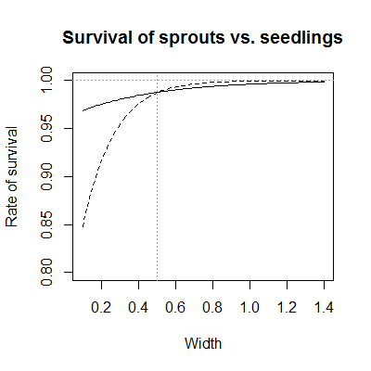

**b)**

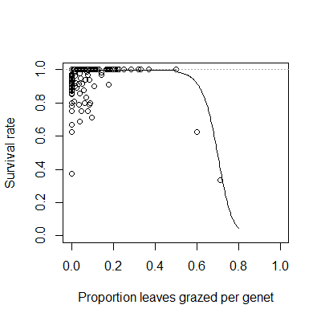

**c)**

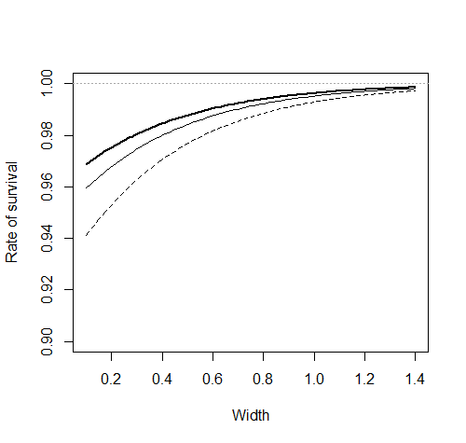**Figure 2.** Modeled variation in ramet size as a function of starting size and a) fire category (thin dashed – exposed to fire in the past year, thin solid – fire within the past 1-2 years, thick solid – no fire within 2 years); b) seedlings (dashed) and ramets (solid); c) genet-level grazing intensity; and d) genet-level harvest intensity.Points show jittered raw growth data. The grey dotted 1:1 line indicates no change in plant size, with points above indicating growth and points below indicating shrinkage.In panel d, points from ramets are shown as gray circles, while points from seedlings or solitary individuals are shown as black crosses.

**a)**

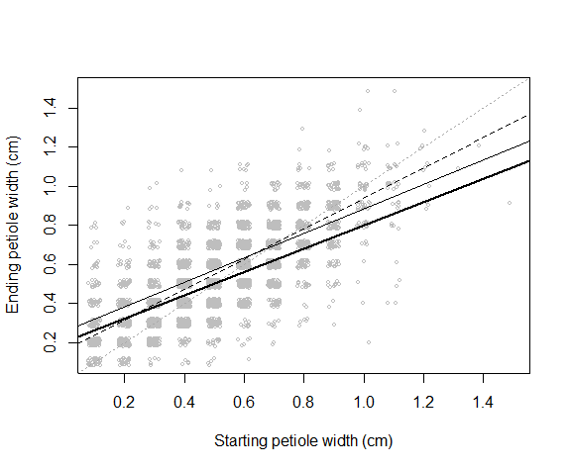

**b)**

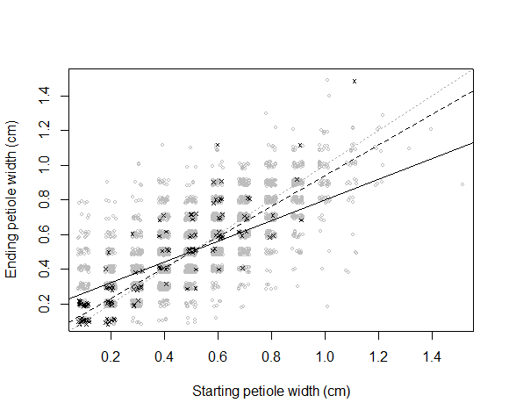

**c)**

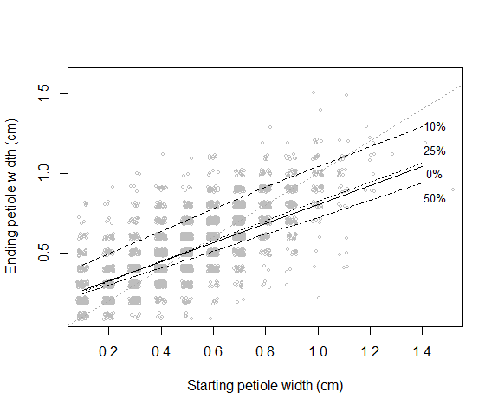

**d)**

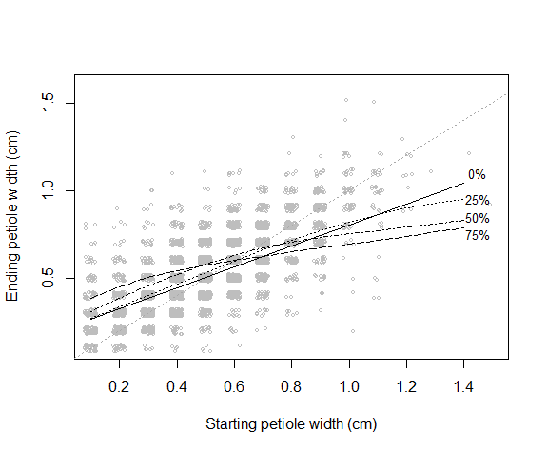

**Figure 3.** Rates of sprout production varied with grazing intensity (a), while the mean and variance of sprout size varied with the size of the mother ramet (b).

**a)**

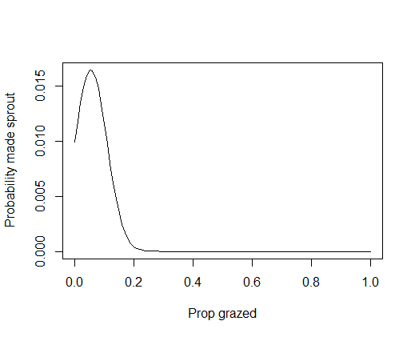

**b)**

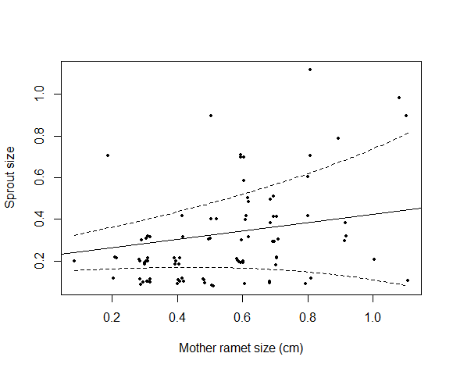**Figure 4.** The probability of flowering a) declined with increasing harvest intensity (solid line – no harvest, dashed line – 25% harvest, dotted line – 50% harvest); and b) increased with fire within the past 1-2 years (thin line), compared to populations without fire for 2 or more years (thick line).

**a)**

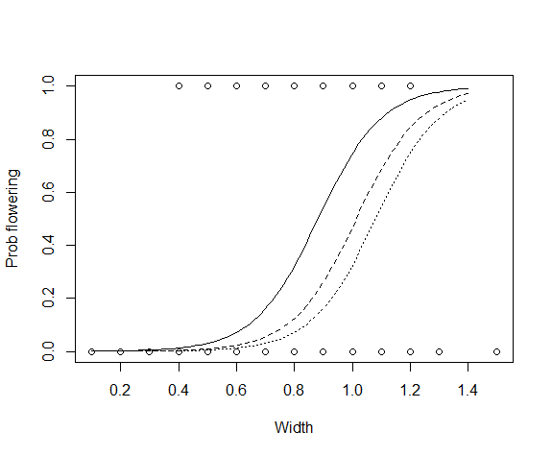

**b)**

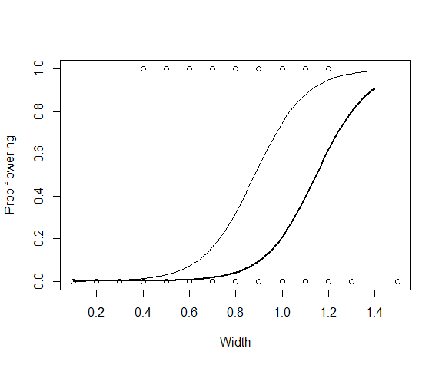

**Figure 5.** The effect of harvest (a and b) and grazing (c) on palm population dynamics by fire category (dashed – exposed to fire within the past year, thin solid – fire within the past 1-2 years, thick solid – no fire for 2 or more years). Panel a shows the effects of harvest assuming an average seedling recruitment across all populations, while panel b shows the effects of harvest using observed seedling recruitment rates by fire category and harvest history (with high harvest rates of recruitment beginning at 30% harvest intensity).

**a)**

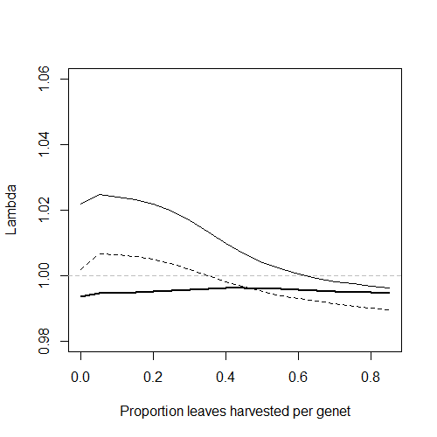

**b)**

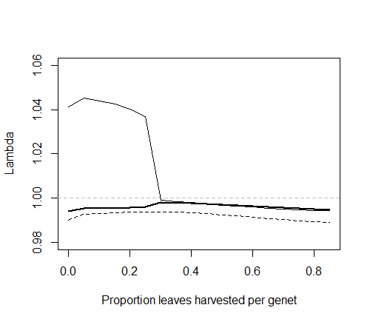

**c)**

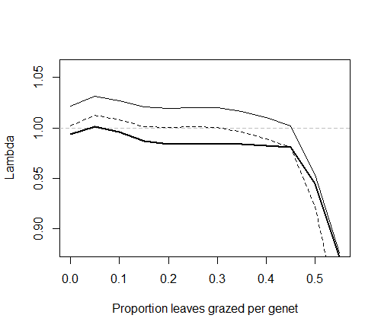

**Figure 6.** The interactive effects of harvest and grazing on the projected population growth rates (λ) of mountain date palms as modeled for populations a) without fire for 2 or more years, b) with fire in the past 1-2 years, and c) exposed to fire within the past year, assuming no effect of harvest or fire on seedling recruitment rates. Panel d shows λ for recent fire conditions using observed seedling recruitment rates by fire category and harvest history (with high harvest rates of recruitment beginning at 30% harvest intensity).

**a) b)**

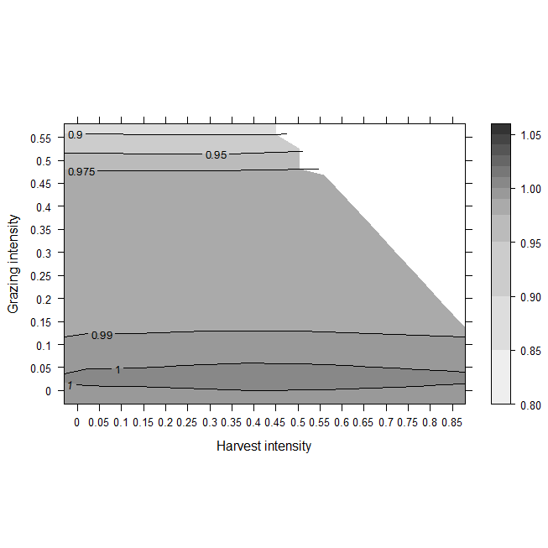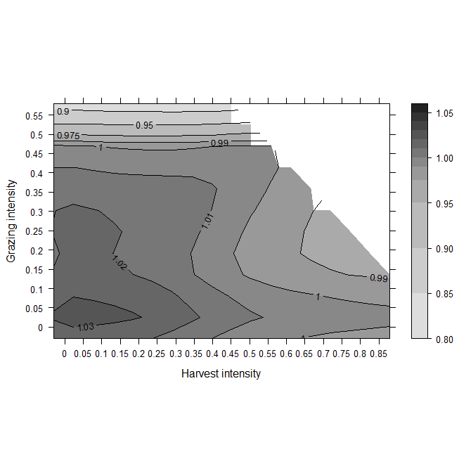

**c) d)**

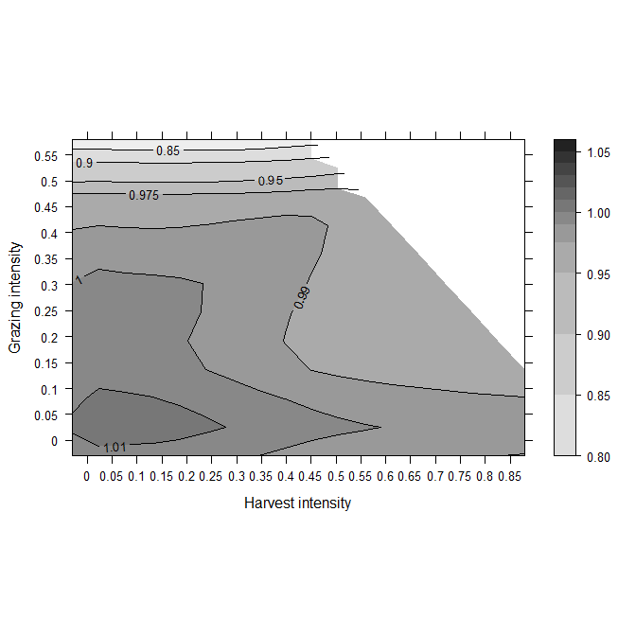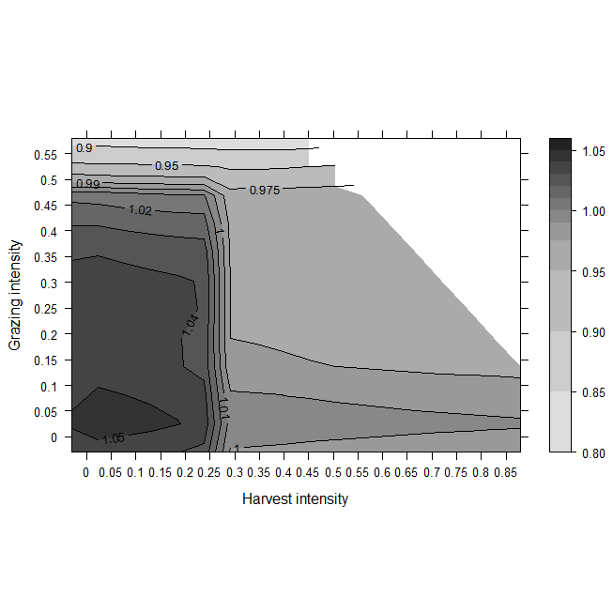

**Figure 7.** Proportion of ramets grazed per population as a function of time since fire. Points are observed proportions jittered to minimize overlap, and differ in shape by year (circle = 2009, triangle = 2010, cross = 2011).

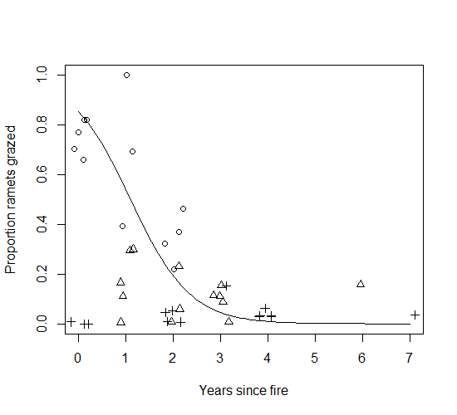

**Table S1.** Specifications of variables tested with linear and generalized linear mixed effects models (LMM and GLMM) for their effects on mountain date palm vital rates.

|  |  |  |  |  |  |  |
| --- | --- | --- | --- | --- | --- | --- |
| **Model** | **Form**  **(R package)** | **Response variable** | **Random effectsa** | **Fixed effects** | | |
|  |  |  |  | *Main effects* | *Covariates* | *Interactions* |
| **Survival** | Binomial GLMM (lme4) | Ramet survived from time *t* to *t*+1(1,0) | Area/population/genet  Year | Fire category  Harvest intensity (genet-level)  Grazing intensity (genet-level) | Ramet size at startb  Ramets per genet  Canopy openness  Seedling (vs. vegetative sprout) | Two-way interactions between main effects and between main effects and covariates (except seedling) |
| **Size at *t* + 1 of surviving ramets** | LMM (lme4) | Ramet size at  *t* + 1b | Population/genet/ramet  Population*Ramet size at startb  Year | Fire category  Harvest intensity (ramet- and genet-level)  Harvest intensity (ramet-level)2  Grazing intensity (ramet- and genet-level)  Grazing intensity (ramet-level)2 | Ramet size at startb  Ramets per genet  Canopy openness  Seedling (vs. vegetative sprout) | Two-way interactions between main effects and between main effects and covariates, (except seedling, genet-level ramet and grazing intensities and quadratic terms) |
| **Probability of flowering at time *t*** | Binomial GLMM (lme4) | Ramet flowered at time *t* (1,0) | Area/population/genet  Year | Fire category  Harvest intensity (ramet-level)  Grazing intensity (ramet-level) | Ramet size at startb  Ramets per genet  Canopy openness | Two-way interactions between main effects and between main effects and covariates |
| **Probability of producing a sprout** | Binomial GLMM (lme4) | Ramet produced sprout (1,0) | Area/population/genet  Year | Fire category  Harvest intensity (genet-level)  Grazing intensity (genet-level) | Ramet size at startb  Ramets per genet  Canopy openness | Two-way interactions between main effects and between main effects and covariates |
| **Mean sprout size at *t* + 1** | LMM (nlme) | Sprout size | Area/population/genet | Fire category  Harvest intensity (genet-level)  Grazing intensity (genet-level) | Mother ramet size at startb  Ramets per genet  Canopy openness | None |

aSome random effects were omitted from some models because of problems with convergence with many nested random effects with estimated variances close to 0.

bMeasured as the petiole width of the longest leaf.

**Table S2.** A model predicting ramet-level grazing and harvest intensities from ramet size and genet-level grazing and harvest intensities.Because palm vital rates were affected by grazing and harvest at both the genet and ramet levels, we used a multinomial model to determine the relationship between the two. Our response variables were the number of grazed, harvested and intact leaves per ramet. Predictor variables included the intensity of grazing and harvest at the genet level, ramet size, and grazing-by-size and harvest-by-size interactions. The multinomial model was fitted with the multinom function in the nnet package in R (Venables and Ripley 2002). The model was reduced using AIC as the criteria for deciding whether to drop or retain individual terms. Our multinomial model showed that grazing and harvest at the ramet level increased with the corresponding level of grazing and harvest at the genet level. For a given genet-level intensity of harvest or grazing, ramet-level intensities of harvest and grazing were greater for larger ramets. Harvest especially had a greater effect on larger ramets.

**Factor Coefficient SE**

*Proportion of leaves grazed per ramet*

Intercept -4.32 0.200

Grazing intensity (genet) 8.88 0.468

Harvest intensity (genet) 0.551 0.788

Starting size 1.61 0.288

Harvest intensity (genet) x starting size 0.00676 1.33

*Proportion of leaves harvested per ramet*

Intercept -4.27 0.197

Grazing intensity (genet) -0.664 0.749

Harvest intensity (genet) 4.99 0.425

Starting size 2.07 0.290

Harvest intensity (genet) x starting size 2.62 0.689

**Figure S1.** Effects of a) grazing; b) harvest, and their combination (c – no fire, d – fire within the past 1-2 years and e – fire within the past year) on projected population growth rates, assuming that true fruiting rates were 1/3 those parameterized from ramets known to be female, and averaging seedlings/stalk across all populations.

**a)**

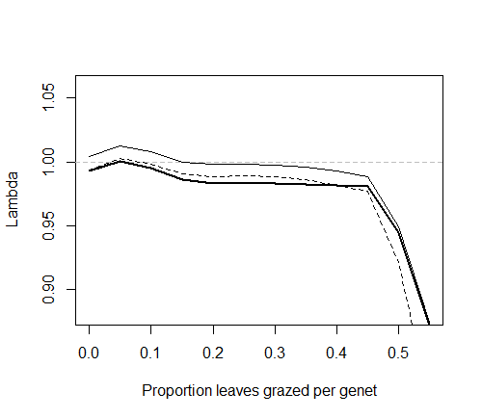

**b)**

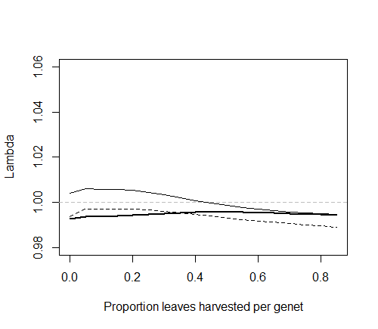

**c) d)**

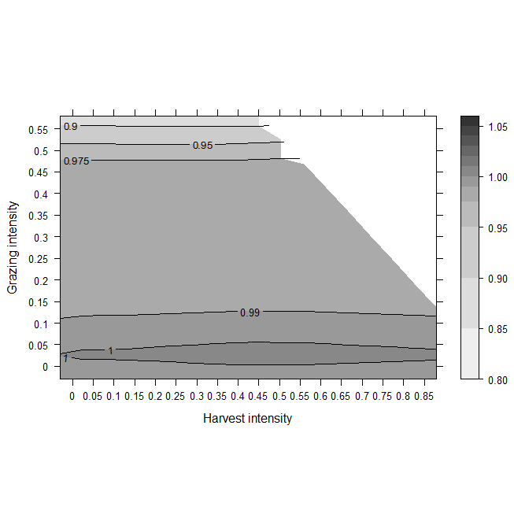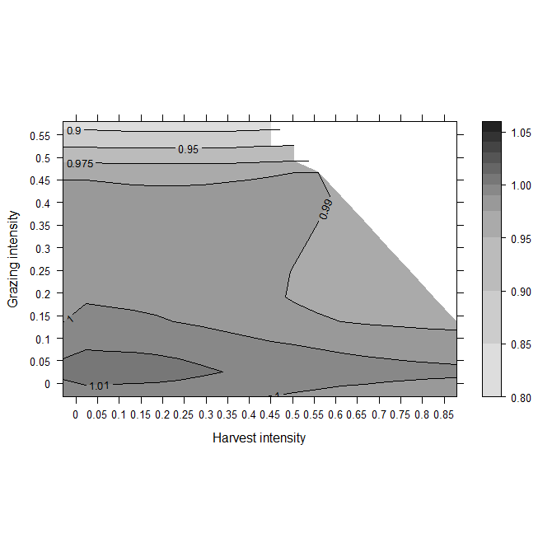

**e)**

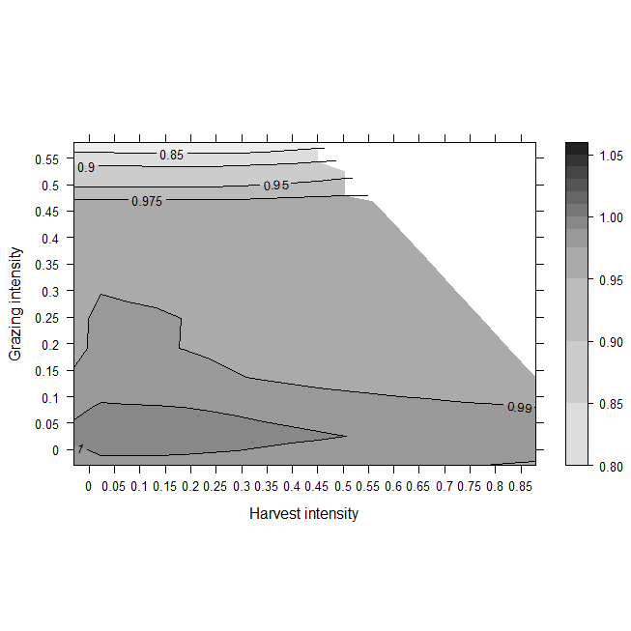

**Figure S2.** Projected population growth rates (λ) as a function of density (ramets/genet), by fire category (dashed – exposed to fire, thin solid – fire within 2 years, thick solid – no fire within 2 years). The vertical dashed line indicates the mean number of ramets per genet observed across our study populations.

